Lodehaul Ltd
2021
Pollution Incident Response
Management Plan

Purpose
LOD Co-Operative Haulage and Transport Trading as LODEHAUL holds an Environment Protection License with the NSW Environment Protection Authority for 190 Shellharbour Road Kemblawarra NSW.
License Number
As per the Protection of the Environment Operations Act (1997) (the “POEO Act”), the holder of an environment protection license must prepare, keep, test and implement a pollution incident response management plan that complies with Part 5.7A of the POEO Act in relation to the activity to which the license relates.
If a pollution incident occurs in the course of an activity so that material harm to the environment (within the meaning of section 147 of the POEO Act) is caused or threatened, the person carrying on the activity must immediately implement this plan in relation to the activity required by Part 5.7A of the POEO Act.
A written copy of this plan must be kept at 190 Shellharbour Road Kemblawarra and be made available on request by an authorised NSW Environment Protection Officer and to any person who is responsible for implementing this plan.

NOTE: This plan must be developed in consultation with:
- NSW EPA’s “Environmental guidelines: Preparation of pollution incident response management plans”; and
- The Protection of the Environment Operations Act 1997 and the Protection of the Environment Operations (General) Regulation 2009.

Contents
Purpose 1
Contents 2
Environmental Protection License Details. 3
Notification of Relevant Authorities 4
Description and likelihood of hazards 5
Inventory of possible pollutants 6
Safety equipment 6
Local Community and Neighbors Notification and communication procedures. 7
Communicating with neighbours and the local community 7
The majority of potential pollutions on site are: 8
Actions to be taken during or immediately after a pollution incident 9
Coordinating with persons 9
Staff training 10
Testing of PIRMP 10
Site Plan 11
Location of Pollutants 12

Environmental Protection License Details.

Name of License | LOD Co-Operative and Haulage LTD  Trading as LODEHAUL | PLAN ACTIVATION | Name: Raquel Moulds  Position General Manager  24 hour contact details  0402 016 699
Environmental Protection License Number : | 12818 | NOTIFYING RELEVANT AUTHORITIES | Name : Paul Busch  Position: Operations  24 hours contact details  0418 237 806
Premises Name and Address | Lodehaul  190 Shellharbour Road  Kemblawarra NSW 2505 | MANAGING RESPONSE TO POLLUTION INCIDENT | Name: Brett Oldfield  Position: Allocations  24 hour contact details  0409 440 296
Company contact details | Name: Raquel Moulds  Position: General Manager  Business Hours 7am > 5pm  Phone 02 4275 1115  After hours contact numbers 0402016699, 0418237806, 0409440296  Email: operations@lodehaul.com.au

Notification of Relevant Authorities

- Incident Notification
- Identify any persons or authorities required to be notified as per Part 5.7A of the POEO Act

Relevant Authorities Include  - Fire and Rescue  - Environment Protection Authority  - Health NSW (nearest public health unit)  - Safe work NSW  - Local Authorities (usually local council) in which the pollution has occurred (Note: The local council and public health unit will vary depending on the location of the pollution incident) | Fire and Rescue | 000
 | Environment Protection Authority | 131555  0299955555
 | Health NSW  Minister for Health Wollongong | 02 9391 9000  02 4222 5000
 | Safe Work NSW | 13 10 50
 | Wollongong Council | 02 4227 7111
Local Authority | Port Kembla Police Station  Wollongong Fire Station | 02 4276 5199  02 4224 2020

Description and likelihood of hazards
Fuel Diesel
Description | Likelihood of hazard Occurring | Pre-emptive actions taken
Risk to environment if released into waterways.  Could be used to fuel a fire  Exhaust Fumes could be harmful if consumed in large amounts | Likelihood of fuel spillage is minimal. | Operations stop immediately if any spillage of minerals occurs.  Spillage to be cleaned up immediately  All fuel is to be stored in the marked areas  Designated fueling area.  Spill kits are kept on the premises and should be used as required.  Fire extinguishers are available.  Personnel will be trained in refueling and operation of mobile equipment
Fuel Petrol
Description | Likelihood of hazard Occurring | Pre-emptive actions taken
Could be used to fuel a fire  Risk to environment if released into waterways  Risk of explosion if not stored properly | Likelihood of fuel spillage is minimal. | Operations stop immediately if any spillage of minerals occurs.  Spillage to be cleaned up immediately  All fuel is to be stored in the marked areas  Designated fueling area.  Spill kits are kept on the premises and should be used as required.  Fire extinguishers are available.  Personal will be trained in refueling and operation of mobile equipment
Soda Ash
Description | Likelihood of hazard Occurring | Pre-emptive actions taken
Soda ash is loaded and unloaded inside shed with conveyor system or front end loader.  Refer to MSDS | Likelihood of spillage is possible.  Likelihood of dust arising from loading operations is probable  Soda Ash is non-toxic and generally considered safe for human consumption.  Soda Ash is used to alter the pH of drinking water | All trucks are loading and unloading inside the shed. Doors of shed are closed to contain dust.  Trucks are blown down before leaving shed to prevent drag out.  All trucks have waterproof dust proof tarps and are rubber seals to prevent spillage from tailgate.  Specially designed hoppers with baffles are used to minimize air displacement.

Inventory of possible pollutants
Possible Pollutants | Qty | Minimizing harm to persons on site.
Diesel Fuel | Max 1000ltrs | Diesel Fuel is stored in a tank which is in turn stored in a large bin to mitigate any uncontrolled leaks.  This in turn is stored inside the warehouse away from any drains.  Fuelling is to take place in the appropriate area.  In the event of a machinery spillage, a spill kit should be used to control the spill as soon as practical.  Major servicing of machinery is to be carried out by a licensed mechanic.
Petrol Fuel | Max 20ltrs | Diesel Fuel is stored in a tank which is in turn stored in a large bin to mitigate any uncontrolled leaks.  This in turn is stored inside the warehouse away from any drains.  Fuelling is to take place in the appropriate area.  In the event of a machinery spillage, a spill kit should be used to control the spill as soon as practical.  Major servicing of machinery is to be carried out by a licenced mechanic.
Hydraulic and engine oils |  | Mobile machinery carriers the manufacturers recommended amounts of oils
Soda Ash | Max  16000tns | Soda Ash is stored in bulk amounts in the confines of the shed.  Soda Ash is also stored in the 1 tons bulk bags and 25kg bags in the confines of the shed.  Soda ash is not classified as toxic, but can irritate the eyes and skin upon contact and be harmful if ingested. As a result exposure should be minimised.  If dust is present the shed can be sealed to eliminate airborne emissions.

Safety equipment
PPE including steel capped boots is mandatory.
Spill controls kits are on site to pick up and contain any spillage within the premises.
Dust mask, eye protection are provided on site for all staff and visitors
Fire extinguishers are on site for emergency use.
Showers are available.

Local Community and Neighbors Notification and communication procedures.

- Boom Logistics | 180 Shellharbour Road Kemblawarra | 02 4276 6666
- BBQ Galore | 131 King Street Warrawong | 02 4276 2211
- Fergo’s Tackle World | 145 King Street Warrawong | 02 4225 7233
- Pet Select | 149 King Street Warrawong | 02 4275 1112
- Best Sheds | 223 Shellharbour Road Kemblawarra | 02 4648 7777

Communicating with neighbours and the local community

In an event of the incident, subject to advice from the regulatory authorities, the following methods of communication are able to be used to communicate with the local community.
Communication Modes
- Call all neighbours
- Signage
- Doorknock
- Update webpage
- Newsletter drop
Decisions to notify neighbours and local community will be made in consultation with regulatory authorise on the initial risk assessment (for example, consider the risk of pollutant)
Advise provided to the community will depend on the type and extant of the pollution incident and guidance from the regulatory authorities.
The types of pollution events likely to occur at the Lodehaul site are unlikely to be a major health risk. The most likely events are to be dust issues.

The majority of potential pollutions on site are:

Fuels, oils and cleaners associated with the maintenance and servicing of machinery.
Appropriate quantities for regular use are stored as per recommendations.

The site specific emergency response procedures include
On site fire
Vehicle liquid spill
External emergencies (flood, earthquake storm etc.)
The site has both spill kits and fire extinguishers.

Soda Ash

Loading and unloading operations are conducted entirely within sheds.
Spillages outside would only occur from trucks.
Truck tail gates are checked and sealed if required in the shed.
Trucks can only leave with waterproof tarping systems.

Actions to be taken during or immediately after a pollution incident

Pollution control action
- If an incident occurs, try to contain the spill or fire.
- Contact the office for help.
- The contact person will contact emergency services if needed.
- The contact person will contact neighbours and the local community if needed.
- Report incident to the EPA.
- When incident is contained:
- Contact neighbours to inform that the incident has ceased.
- Investigate cause of incident and create CAR to prevent reoccurrence.
- Implement CAR.
- Write report.
- Clean up site if required using qualified personnel.
- Train personnel if required on incident.
In the case of a diesel or fuel spill, persons involved in the clean-up should use the appropriate PPE.
If a diesel fire is present proper breathing equipment should be worn. Persons suffering nausea after exposer to the fumes should be taken to an area devoid of any smoke and fumes.
In the case of a fuel spill, every effort should be made to eliminate access to waterways. Spill kits should be used to contain any spill.
In the case of a fuel fire: try to put it out using the appropriate equipment if the fire is out of control contact the local fire department.
If the fire is going to impact on the adjoining properties the owners must be informed of the incident.
The site clean-up should be undertaken asap so as to avoid any further impact on the environment.

Coordinating with persons
Notify the authorities of any spills if the incident warrants as per numbers at top of form.
If neighbouring properties are affected notify neighbours through the emergency response plan.
Inform the local community if incident warrants.
All communications to go through the notifying person.

Staff training
Staff are inducted into the worksite, and trained in this plan.
Staffs are trained in driving and fuelling the mobile machinery.
External mechanics used are licenced mechanics.

Testing of PIRMP
This plan will be tested routinely every twelve month period, or within one month of any pollution incident occurring in the course of an activity to which the licence relates.
Test will incluided the following procedures.

- Is all the information within the plan accurate and up to date?
- Are all the sections of the plan workable, and can they be implemented in an effective manner.
These questions will be asked at the annual staff training. If there is not an affirmative answer to these questions, management will ensure the plan is revised and updated.
The plan will be revised within two months if these questions cannot be answered affimatively.
Reason For Testing | Date of Test | Persons Present | PRIMP Updated
Annual Test | 08.07.19 | Paul Bush, Raquel Moulds | No other updates required
Update Only | 16.12.19 | Raquel Moulds, Paul Bush, | Neighbours Details Updated.  No other updates required.
Annual Test | 03.08.2020 | Raquel Moulds  Paul Busch | No other updates Required
Update Check Only | 17.02.2020 | Raquel Moulds  Paul Busch | No updates Required

Site Plan
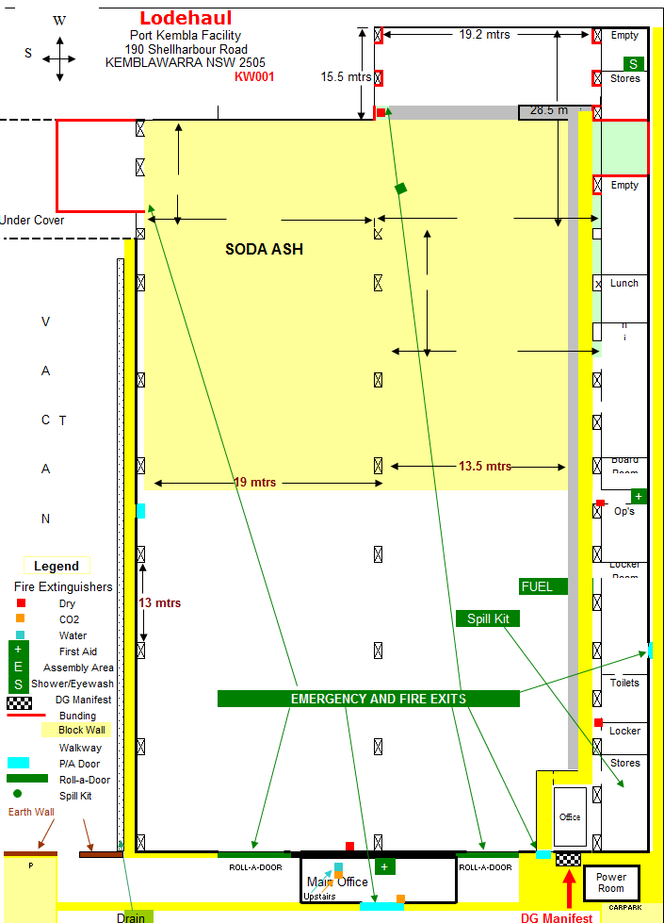

Location of Pollutants
